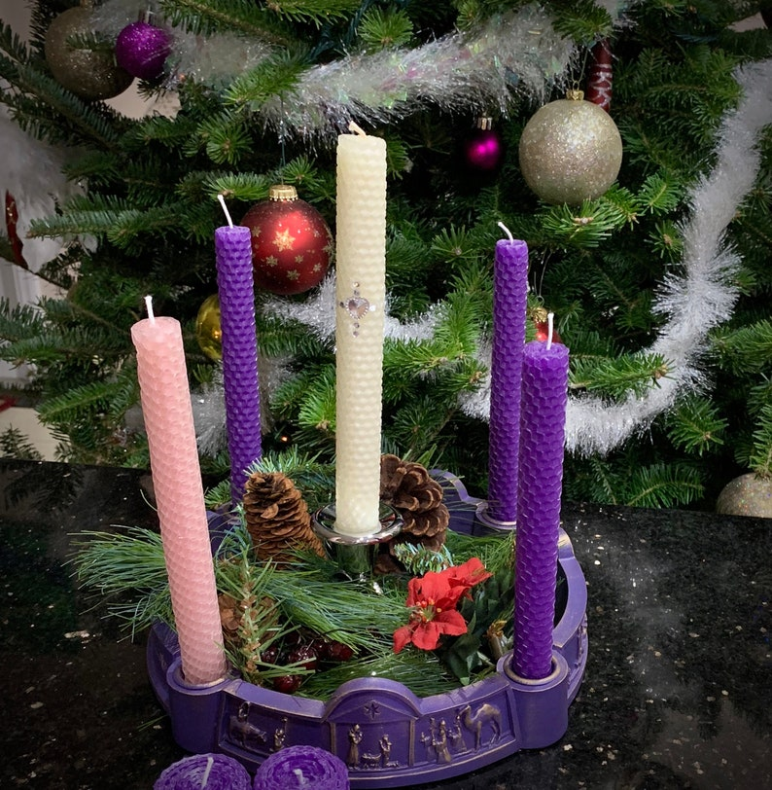
Parish of Dunshaughlin and Culmullen

Fourth Sunday of Advent

22nd of December 2024
Parish Newsletter
Priest of the Parish: Fr. Seán Henry P.P. Fr. Joseph Clavin A.P.
Parish Office; Pastoral Centre (Monday – Friday 10am until 2pm)
Phone 01 8259114 or email office@dcparish.ie
Pastoral Centre: Phone 01 802 4780 or email pcmanager@dcparish.ie
Religious Shop; open everyday in the Pastoral Centre
Website www.dunshaughlin-culmullenparish.ie
Webcam - dunshaughlin-culmullenparish.ie/our-parish/webcam (live stream only)
Dunshaughlin Masses: Saturday Vigil Mass 7pm, Sunday 9 am, 12 noon
Culmullen Masses: Saturday Vigil 6pm Sunday 10:30am
Weekday Masses: Culmullen 9am, Dunshaughlin 10am
Confessions: Saturday 12noon - 1pm.
Eucharistic Adoration: Dunshaughlin: Tuesdays 10:30am until 2 pm; 7-9 pm Culmullen: Thursdays 9:30am - 11 am
Baptisms: Dunshaughlin Church: 1st Saturday and 4th Sunday of the month.
Culmullen Church: 2nd Sunday of the month. Ceremonies are at 2pm.
Baptism Programme: Call Íde Ó Dúshláine 087 – 153 2994 to book a place.
Mass Intentions for the coming week
Saturday 21st December | Cul Vigil 6pm | Lauri Byrne;
Saturday 21st December | Dunsh Vigil 7pm | Dec’d Family members of the Madden Family;  Eithne & Thomas Hetherington;
Sunday 22nd December | Dunsh 9am | Bridget Johnson & Dec’d Family members;  Billy, Dympna & Jimmy McCormack;
Sunday 22nd December | Cul 10:30am | Alison Kelly – O’Riagaín;
Sunday 22nd December | Dunsh 12noon | Claire Casey & Breda Walsh;  Thomas & Mary Cahill;
Monday 23rd December | Dunsh 10am | Philip Toolan;
Thursday 26th December | Dunsh 10am | Kathleen Jordan;
Friday 27th December | Dunsh 10am | Ruby & Patrick Mannion & Stephen Law;
Saturday 28th December | Dunsh 10am | Ammini Tomy;
Saturday 28th December | Dunsh Vigil 7pm | William & Kathleen Murphy & Dec’d Family Members;
Sunday 29th December | Cul 10:30am | Cornelius & Ann O Shea;
Sunday 29th December | Dunsh 12noon | Michael, Ellen & Catherine McHale;  Angie & Bernard Reilly & Dec’d Family Members;

Fourth Sunday of Advent
We light our fourth candle on this last Sunday before Christmas.
Like Elizabeth and Mary we prepare to welcome the nativity of Jesus

December Offerings: For the support of the Priests of the parish will be taken up at all Masses this weekend. Please use the offerings envelope marked December Offerings or a plain envelope with your name and address on the outside. Thank you for your support.

Meet and Greet
All are invited for a cuppa & a chat in the Pastoral Centre, Dunshaughlin
this Sunday after 12noon mass.
We Remember in Prayer
Pray for the happy repose of the soul of Gerry Norman, Manor Court and Malahide.
May he rest in peace.

Programme for Christmas

Penential service Dunshaughlin Church;
Monday 23rd of December from 7pm-8pm.

Confessions Christmas Eve After 10am & from 12noon till 1pm.

Christmas Masses; Christmas Eve: Dun 6 pm Children’s Mass, and 9 pm Mass of the Nativity. Christmas Day: 9 am and 12 noon
Christmas Carols from 8.15pm on Christmas Eve

Culmullen Christmas Eve: 8 pm Christmas Day 10.30am

Bambinelli Sunday
The Advent tradition, Bambinelli Sunday was introduced by Saint Pope John Paul 11. The tradition follows that on the Sunday before Christmas, children (adults) are invited to bring their baby Jesus figures from their crib at home to be blessed in their local Church.
Mass Servers
We welcome new servers who have started recently; we thank their parents for facilitating them and bringing them to the Masses. Servers are invited to serve whatever Mass suits them and their parents on Sat/Sun.

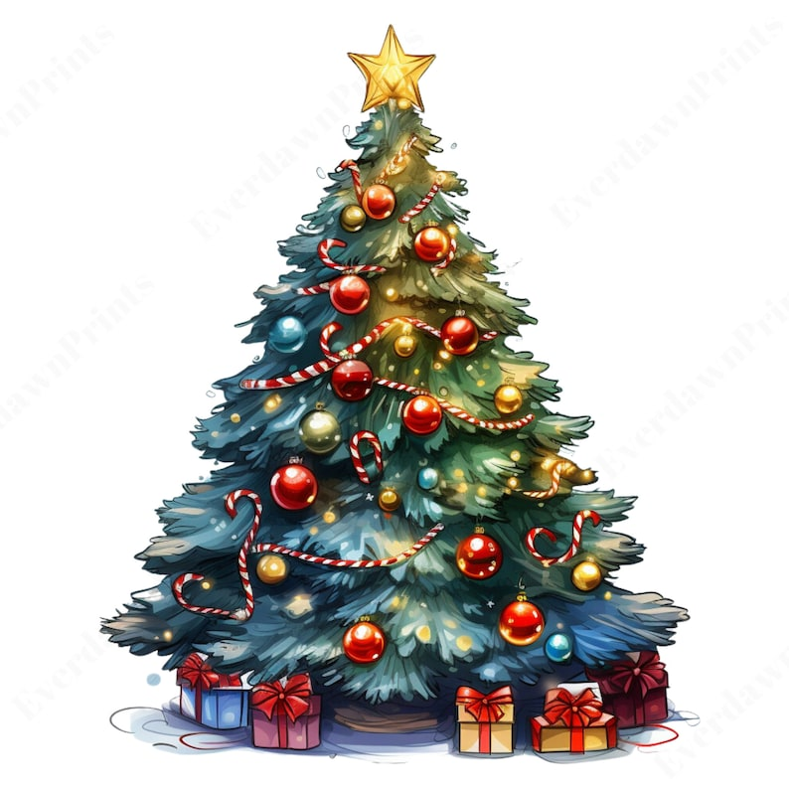
Family blessing for a Christmas Tree
God of all creation, we praise you for this tree which brings
beauty and memories and the promise of life to our home.
May your blessing be upon all who gather around this tree,
all who keep the Christmas festival by its lights.
We wait for the coming of the Christ,
the days of everlasting justice and of peace.
You are our God, living and reigning, for ever and ever. Amen.

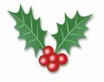
Christmas Blessings
Fr Sean and Fr. Joe wish all our Parishioners a very happy,
and peaceful Christmas. May the Lord bless all of you and
your families this holy Season.
Happy Christmas: Nollaig Shona, Buon Natale, Wesołych Świąt.

Hymn for Sunday Masses - Please join in
O Come Emmanuel
  O come, O come, Emmanuel  And ransom captive Israel  That mourns in lonely exile here,  Until the Son of God appears.  Rejoice, rejoice, Emmanuel shall come to thee, O Israel | come, O come thou Lord of might,  Who to thy tribes on Sinai’s height  In ancient times didst give the Law,  In cloud and majesty and awe.  Rejoice....

